**TASK 1**

**Objective:**

Write a program that contains one user defined function Message.In main function you have to take name as input and print Hello name.In Message function you have print following message.

*********************************

Welcome to Computer Programming class

*********************************

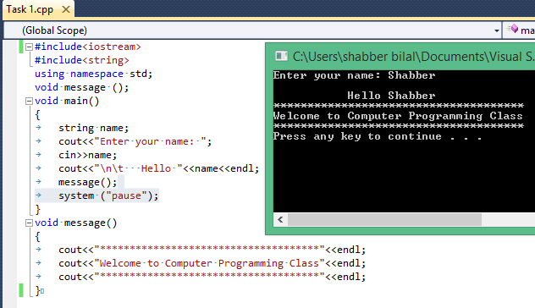

**TASK 2**

**Objective:** Write a program that calculates the factorial of number provided by user using function.

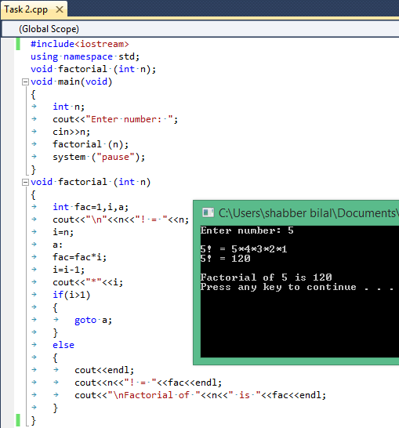

**TASK 3**

**Objective:** Write a program that finds whether the number provided by user is even or odd using function.

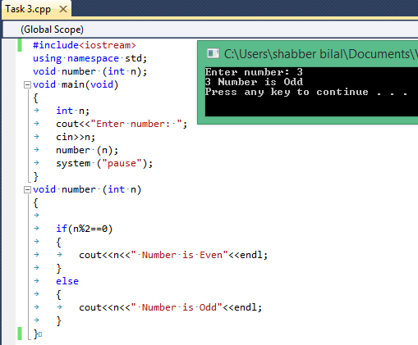

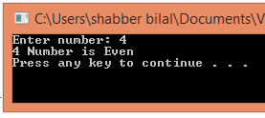

**TASK 4**

**Objective:**

Write a C++ Program that contains five user defined function(s) plus(), minus(), multiply(),

divide(),remainderTake two integer number as input and perform addition subtraction multiplication division,remainder using functions

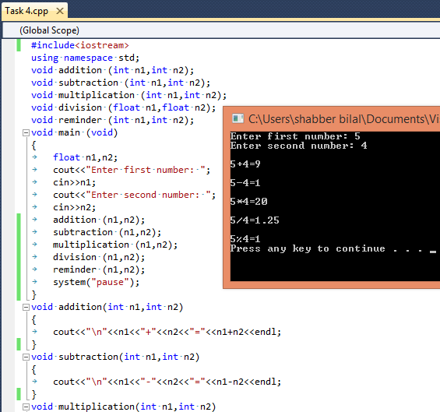

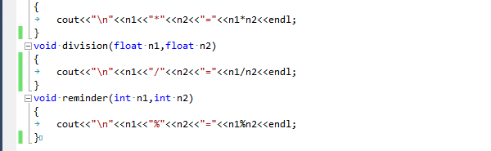

**TASK 5**

**Objective:**

Write a C++ Program that contains one user defined function month().

In main() function: Read an integer input in between (1 to 12) and store it month_of_year. Call month(month_of_year) In month() function: Print the corresponding month of year in month().

Example: Value of parameter is 4… Print “April”.

